MEDIA ALERT

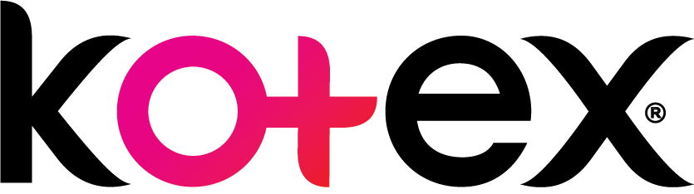
A Sisterhood of Support: Kotex offers feminine care for women and girls in need through #KotexSheCanFund

Since its inception in 1920, Kotex has been aiding women in times of need and as the leading feminine intimate care brand, it has remained close to many Malaysian women’s hearts. Kotex not only supports women on their monthly periods with its wide range of Feminine Hygiene products but also partners with women to help them realize their passion, enrich their lives, and the ones around them through the #KotexSheCanFund In the spirit of championing women and their progress, Kotex is supporting Vimala Kanagaratnam, a Malaysian citizen as well as a few other local entities in their effort in providing Feminine Hygiene products to women and girls in need.

The current pandemic and the social distancing efforts have not been all fun and games for everyone. While it involves lots of self-care, baking and even trying out social media challenges for some, it has been a difficult time for many others as they deal with responsibilities to provide for themselves and their families. While Malaysians have provided aid in various ways for frontliners and those in need, Vimala, Selangor & Wilayah Persekutuan Family Reproductive Health Association (SWP FReHA) and Community Transformation Initiative recognised the needs of women who have their monthly periods, especially those who are located within the Enhanced Movement Control Order (EMCO) zones.

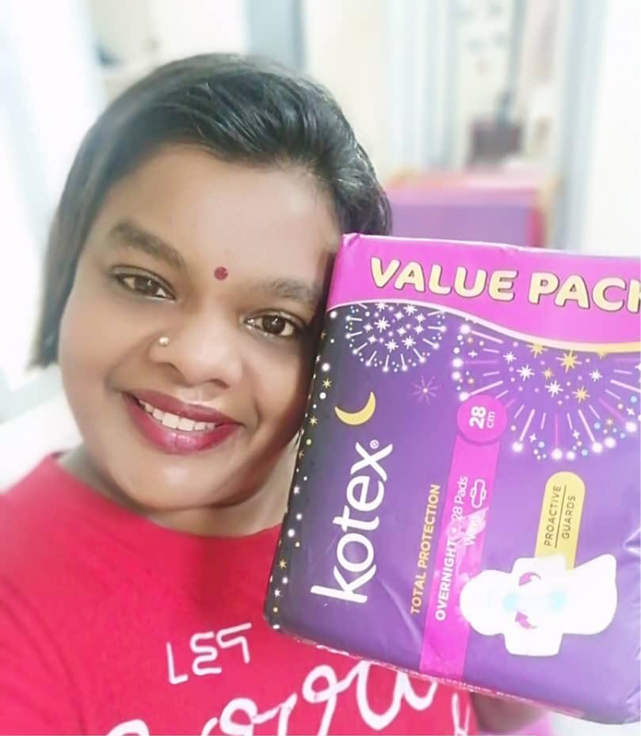

Kotex caught wind of Vimala’s commendable initiative of delivering Feminine Hygiene products to women and girls who were unable to access or afford it during the Movement Control Order (MCO) from a recent article published by a local media. Vimala’s effort is in line with Kotex’s belief in women supporting women and through the #KotexSheCanFund, Kotex gives deserving women a platform to achieve what they set their hearts on.

To support Vimala and the sisterhood she aids, the #KotexSheCanFund is providing Vimala’s initiative with 384 packs of Kotex Feminine Hygiene products, amounting to more than 6,100 pads, to be distributed to communities in People’s Housing Project (Program Perumahan Rakyat) located in Klang Valley. The Feminine Hygiene products will be distributed to families, young girls and adult women of B40 communities who are faced with little to no income during the Movement Control Order.

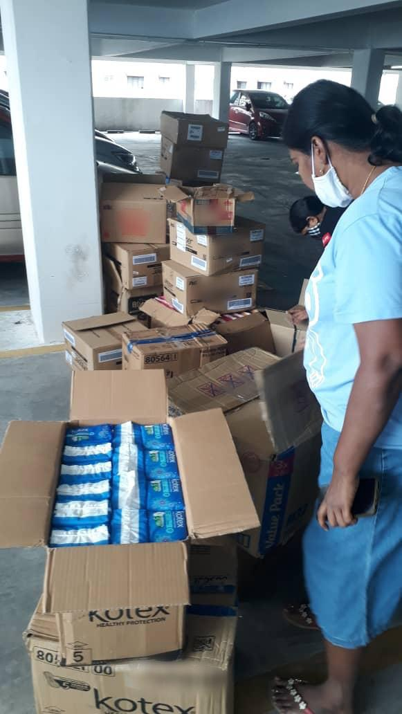

“We recognize Vimala’s passion to help others. She embodies the Kotex philosophy of women helping other women” said Frenissa Lagman, Marketing Manager for Kimberly-Clark Malaysia. Within the first 24 hours of her initiative, she received a commitment of 7 packs of Feminine Hygiene products from her network. Now a month later, her initiative has received more support from not only the greater community but also from Kotex.

Kotex’s SheCanFund is also providing 120 packs of Feminine Care products to SWP FReHA and Community Transformation Initiative respectively. A total of over 3,800 pads will be delivered to women and girls in B40 Communities and refugee communities located within the Klang Valley.

“We celebrate the efforts of Vimala, SWP FReHA and Community Transformation Initiative with these grants through the Kotex She Can Fund and hope that they will continue to inspire more women and girls to support other women and girls. It’s always a joy to see the power of sisterhood shine, sharing the spirit of Kotex #SHECAN,” added Frenissa.
###

About Kotex Malaysia She Can Fund

Apart from eliminating period worries, #KotexSheCanFund was set up to inspire women and help them achieve their passion, not just to enrich their own lives but those around them too.The #KotexSheCanFund nudges ambition into reality. Giving deserving women a platform to achieve what they set their hearts on.

About Kotex
Kimberly-Clark created the feminine care category with the launch of the Kotex brand 100 years ago. Now, Kotex®, a full line of feminine care pads, liners and tampons, continues to push category boundaries. By providing outstanding protection and unique design, the brand brings women a better feminine care experience overall. For more information on Kotex visit Kotex.com.my

About Kimberly-Clark
Kimberly-Clark (NYSE: KMB) and its trusted brands are an indispensable part of life for people in more than 175 countries. Fueled by ingenuity, creativity, and an understanding of people's most essential needs, we create products that help individuals experience more of what's important to them. Our portfolio of brands, including Huggies, Kleenex, Scott, Kotex, Cottonelle, Poise, Depend, Andrex, Pull-Ups, GoodNites, Intimus, Neve, Plenitud, Viva and WypAll, hold the No. 1 or No. 2 share position in 80 countries. We use sustainable practices that support a healthy planet, build stronger communities, and ensure our business thrives for decades to come. To keep up with the latest news and to learn more about the company's 148-year history of innovation, visit kimberly-clark.com .

