DISCOVERY CHANNEL’S COVID-19 DOCUMENTARIES: MAKING SENSE OF THE PANDEMIC THAT HAS SPARKED A GLOBAL EMERGENCY
Speaking with experts, doctors, nurses, patients and volunteers on the front line of this health crisis, the series of documentaries will shed light on the outbreak that’s sweeping around the world

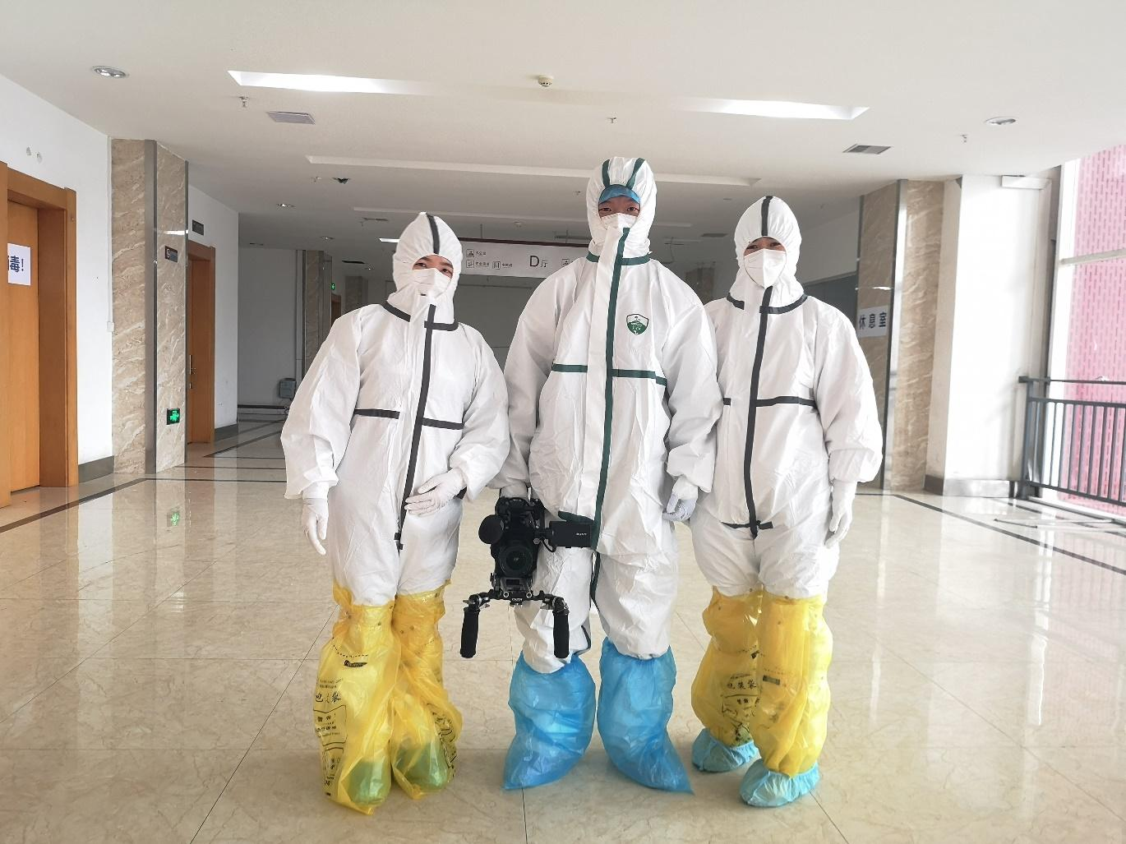

Malaysia, 7 April 2020 – 23 January 2020 is a date which will go down in history. It is the day where China took a historic step to quarantine an entire city of over 11 million people in a bid to stop a virus with the devastating potential to threaten the globe. But in just two months, the coronavirus pandemic has taken over the world, shutting down countries and impacting the lives of billions.

It came without a warning and it is spreading like wildfire. To shed light on this new invisible enemy against humanity, Discovery Channel is bringing in experts to help answer important questions around this defining global health crisis of our time. Across two documentary specials, the COVID-19 programming aims to break down the latest developments and share the stories and lessons of those battling the devil itself.

COVID-19: Battling the Devil
Airing on Sunday, 19 April at 9pm, is "COVID-19: Battling the Devil'' [Discovery Channel Astro Channel 572/552 (HD)]. The programme profiles the minutes that led to the mass quarantine of Wuhan, the Chinese city at the epicentre of the pandemic.

With unrivalled access to Wuhan city under lockdown, and to frontline doctors, scientists, volunteers and public officials, the documentary transports viewers inside the world’s biggest lockdown, as scientists race to understand and contain the virus. Through on-location interviews, the programme tells the story from inside the city: the tension and stress, courage and commitment of the citizens of Wuhan.

Through interviews with key players with simple re-enactments, experience first-hand what it took China to sift through genomes, economic impact, medical readiness, painstaking risk assessments and conflict of opinions. What we’ve learned from those first few weeks is now crucial to understanding what we’re facing today. These lessons could help the rest of the world in the battle to come.

Pandemic: COVID-19
The second programme, “Pandemic: COVID-19”, is set to premiere on Sunday, 26 April [9pm, on Discovery Channel Astro Channel 572/552 (HD)]. This hour-long special examines how, within a matter of weeks, COVID-19 spread throughout China and beyond, alarming healthcare professionals and scientists.

The programme will delve inside the fight to contain the pandemic with the latest news on how authorities across the world are coordinating to test and treat patients, and to prevent further spread. From the virus’ transmission to treatment, experts will reveal why COVID-19 is unique, why the world was so unprepared for it and what could be done differently to contain its spread.

The special also traces the origin of the outbreak in the United States to the first patient, its rapid spread in Seattle and probes the dramatic and unexpected transmission across the country. Discover the effects of the drastic measures happening across America as institutions, schools and businesses shut down to prevent transmission. Hear first-hand accounts from the experts in medicine on the frontlines as well as academia, government officials and patients.

Viewers can join the conversation on social media by following Discovery on
- Facebook (facebook.com/DiscoverySEAsia)
- and Instagram (instagram.com/discovery_seasia) for the latest updates.

Additional Information

Annex A: Synopsis of COVID-19 documentaries on Discovery Channel

About Discovery Channel
Discovery Channel is dedicated to creating the highest quality non-fiction content that informs and entertains its consumers about the world in all its wonder, diversity and amazement. The network, which is distributed to 88.3 million U.S. homes, can be seen in 224 countries and territories, offering a signature mix of compelling, high-end production values and vivid cinematography across genres including, science and technology, exploration, adventure, history and in-depth, behind-the-scenes glimpses at the people, places and organizations that shape and share our world. For more information, please visit www.discovery.com.

About Discovery
Discovery, Inc. (Nasdaq: DISCA, DISCB, DISCK) is a global leader in real life entertainment, serving a passionate audience of superfans around the world with content that inspires, informs and entertains. Discovery delivers over 8,000 hours of original programming each year and has category leadership across deeply loved content genres around the world. Available in 220 countries and territories and nearly 50 languages, Discovery is a platform innovator, reaching viewers on all screens, including TV Everywhere products such as the GO portfolio of apps; direct-to-consumer streaming services such as Eurosport Player, Food Network Kitchen and MotorTrend OnDemand; digital-first and social content from Group Nine Media; a landmark natural history and factual content partnership with the BBC; and a strategic alliance with PGA TOUR to create the international home of golf. Discovery’s portfolio of premium brands includes Discovery Channel, HGTV, Food Network, TLC, Investigation Discovery, Travel Channel, MotorTrend, Animal Planet, Science Channel, and the forthcoming multi-platform JV with Chip and Joanna Gaines, Magnolia, as well as OWN: Oprah Winfrey Network in the U.S., Discovery Kids in Latin America, and Eurosport, the leading provider of locally relevant, premium sports and Home of the Olympic Games across Europe. For more information, please visit corporate.discovery.com and follow @DiscoveryIncTV across social platforms.

ANNEX A:

SYNOPSIS OF UPCOMING COVID-19 DOCUMENTARIES ON DISCOVERY CHANNEL

COVID-19 - Battling the Devil
(Airing on Sunday, 19 April at 9pm on Discovery Channel Astro Channel 572/552 (HD))

Synopsis: 23rd January 2020. China takes a historic step to quarantine an entire city. Nine million people were living in the central city of Wuhan and locking the whole city down was a daring, though extreme measure, to try to stop a virus threatening not just China, but the world. With unrivalled access to Wuhan city under lockdown, and to the doctors, scientists, volunteers and public officials on the front line in this battle to defeat a new public enemy, this documentary charts the growing concern in China in the lead up to lockdown, as scientists race to understand and control the virus. In honest interviews on location, we discover the story inside the city after lockdown: the tension and stress, the courage and the commitment of the people of Wuhan. And find out how lessons learnt here could help the rest of the world in the battle to come.

Pandemic: COVID-19
(Premieres Sunday, 26 April at 9pm on Discovery Channel Astro Channel 572/552 (HD))

Synopsis: Deadly Coronavirus is sweeping around the world. An outbreak in the United States is inevitable. From the first reports of an unknown virus causing pneumonia cases in China on New Year’s Eve, more than 80,000 people have been infected and the death toll is rising daily. Borders are being closed, flights cancelled, schools shut down and cities and towns are put on lockdown to try to prevent contamination, but still, the disease is spreading. The virus is already in the US, with seven states dealing with confirmed cases. It is fatal and it is spreading. As well as posing a health emergency, the coronavirus is causing an economic emergency with global supply chains for companies like Amazon, Apple and Nissan grinding to a halt, and shares taking a dive. So, what can Americans do to protect themselves? How will the virus be controlled? And how far away is a cure or a vaccine?

